Data Science Team Trello Tutorial

This tutorial is about Data Science Team how to use Trello to create personal cards.

# Register

Please don't use a personal email account. We need a name to confirm identity. For the first time, through the tab on the company channel. Easy to register with a school account. Invitation sent via email.

# Trello list

Templates are card templates for each team. Please do not change them. Backlog list is a historical backlog of tasks. In-progress list is a list that is being advanced. Completed are lists that have been completed.

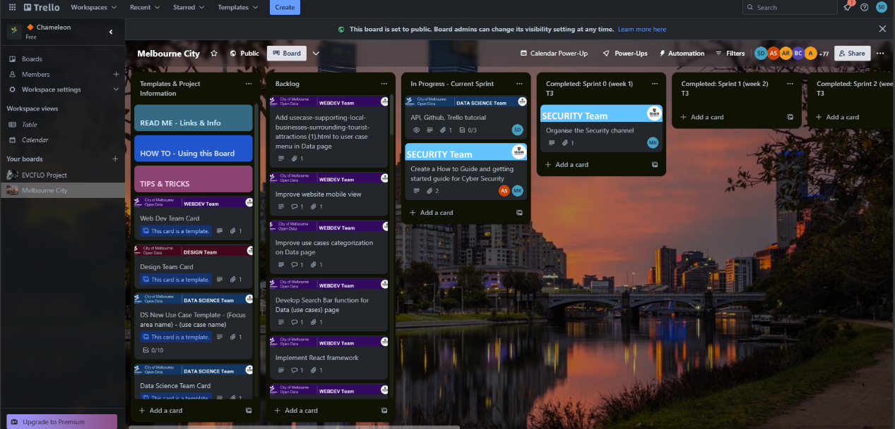

# Personal cards

First, find the template for data science.

After that, we selected one model card We used the Team Card to demonstrate the work.

Copy on the right side after opening.

Select to copy the template to the third row of the in-process list of the Melbourne city page.

Then, move to the third line of in-process to continue editing.

Click on the right to join. This card will display your name. You can change the card name and description yourself.

If there are multiple subtasks, please click the checklist on the right. You can create your task list or copy someone else's list in the project.

After creating the list of subprojects, add the subprojects. If you want to describe your task stage, you can enter a comment in the Activity.

## Complete card

When you complete all sub-projects, the card will be marked Completed. If you confirm that you have completed the card, move it to the completed list for the current sprint.

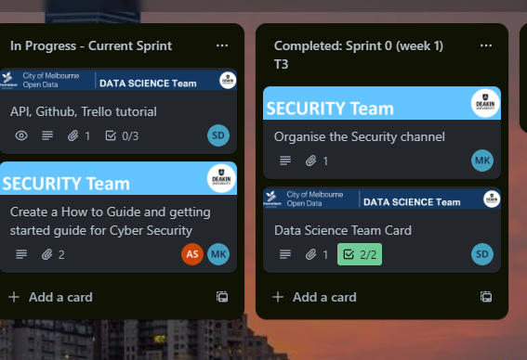

# Author

Siju Deng